*Heaven’s Light is Our Guide*

**Rajshahi University of Engineering & Technology**

Department of Electrical & Computer Engineering

Course No: ECE 4124

Course Title: Digital Signal Processing Sessional

Experiment No: 02

Experiment Name: Correlation of Signals

|  |  |
| --- | --- |
| **Submitted by:**  Name: Md. Zayed Al Masud  Roll: 1810016  Date of Experiment: 03. 05. 2023  Date of Submission: 15. 05. 2023 | **Submitted to:**  Hafsa Binte Kibria  Lecturer,  Dept. of ECE |

**Theory:**

Correlation is a mathematical operation that is very similar to convolution. Correlation is an operation used in many applications in digital signal processing. It is a measure of the degree to which two sequences are similar.

Depending on whether the signals considered for correlation are same or different, we have two kinds of correlation:

1. Auto-Correlation,
2. Cross-Correlation.

Auto-Correlation:

This is a type of correlation in which the given signal is correlated with itself, usually the time-shifted version of itself.

The autocorrelation of the discrete time signal $x(n)$ is expressed as,

$$r_{xx}=\sum_{n= -∞}^{∞}{x\left(n\right)*x(n-m)}$$

Cross-Correlation:

This is a kind of correlation, in which the signal in-hand is correlated with another signal so as to know how much resemblance exists between them.

The Cross-Correlation of the discrete time signals $x(n)$ and $y(n)$ is expressed as,

$$r_{xy}=\sum_{n= -∞}^{∞}{x\left(n\right)*y(n-m)}$$

**Code:**

Auto-Correlation:

|  |  |
| --- | --- |
| 1. clc; clear all; close all; 2. x=input('enter the sequence'); 3. h = fliplr(x); 4. z = []; 5. for i=1:length(x) 6. g = h.*x(i); 7. z = [z g]; 8. end 9. z1=reshape(z,length(x),length(x),[]); 10. z2=z1'; 11. z3 = flip(z2); 12. cd = 0; 13. y = []; 14. for i=length(x)-1:-1:-(length(x)-1) 15. cd=sum(diag(z3,i)); 16. y=[y cd]; 17. cd = 0; 18. end 19. auto_correlation = flip(y); 20. auto_correlation | 1. subplot(2,1,1) 2. stem(x,'filled') 3. ylabel('Amplitude') 4. xlabel('Samples') 5. title('X(n)') 6. subplot(2,1,2) 7. stem(auto_correlation,'filled') 8. ylabel('Amplitude') 9. xlabel('Samples') 10. title('Auto Correlation') |

Cross-Correlation:

|  |  |
| --- | --- |
| 1. clc;clear all;close all; 2. x= input('enter first sequence'); 3. h = input('enter second sequence'); 4. h1=fliplr(h); 5. z = []; 6. for i=1:length(x) 7. g = h1.*x(i); 8. z = [z g]; 9. end 10. z1=reshape(z,length(x),length(x),[]); 11. z2=z1'; 12. z3 = flip(z2); 13. cd = 0; 14. y = []; 15. for i=length(x)-1:-1:-(length(x)-1) 16. cd=sum(diag(z3,i)); 17. y=[y cd]; 18. cd = 0; 19. end 20. cross_correlation = flip(y); 21. cross_correlation | 1. subplot(3,1,1) 2. stem(x,'filled') 3. ylabel('Amplitude') 4. xlabel('Samples') 5. title('X(n)') 6. subplot(3,1,2) 7. stem(h,'filled') 8. ylabel('Amplitude') 9. xlabel('Samples') 10. title('H(n)') 11. subplot(3,1,3) 12. stem(cross_correlation,'filled') 13. ylabel('Amplitude') 14. xlabel('Samples') 15. title('Cross Correlation') |

**Output:**

For auto-correlation:

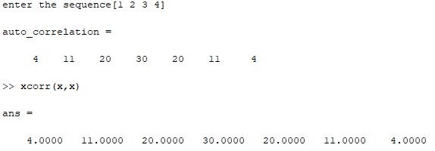

Fig 2.1: Auto Correlation Output

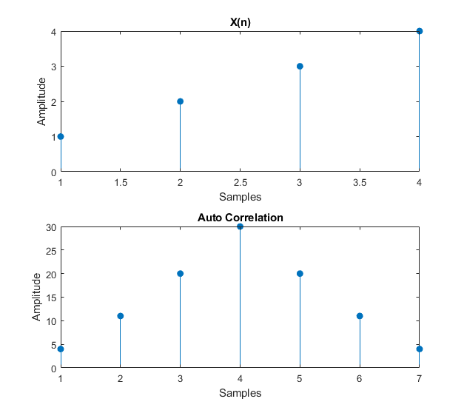

Fig 2.2: Auto Correlation Plot

For cross-correlation:

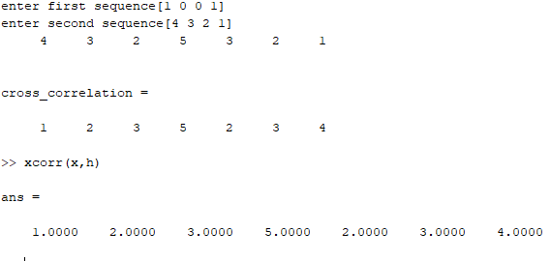

Fig 2.3: Cross Correlation Output

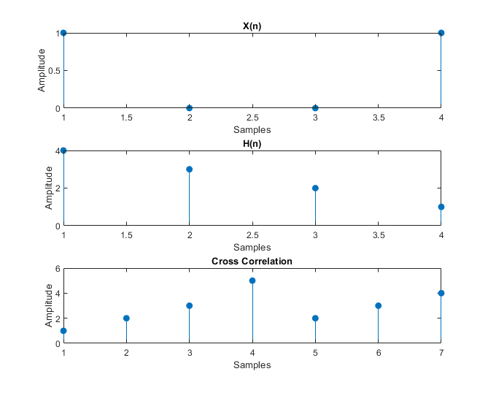

Fig. 2.4: Cross Correlation Plot

**Conclusion:**

In this experiment we were familiarized with auto-correlation and cross-correlation. We implemented both of these operation in MATLAB and verified the produced result by comparing with built in function output.